**Computer Network (01CE0410)**

**Lab Manual (2024-25)**

**Name: Kavar Prince A.**

**ER No.: 92410103120**

**Class: 4 EC5**

**Lab Batch: C**

**Practical 3:** Demonstrate basic networking commands and Network configuration commands.

1. **ipconfig – Displays basic IP configuration details of the system's network adapters.**

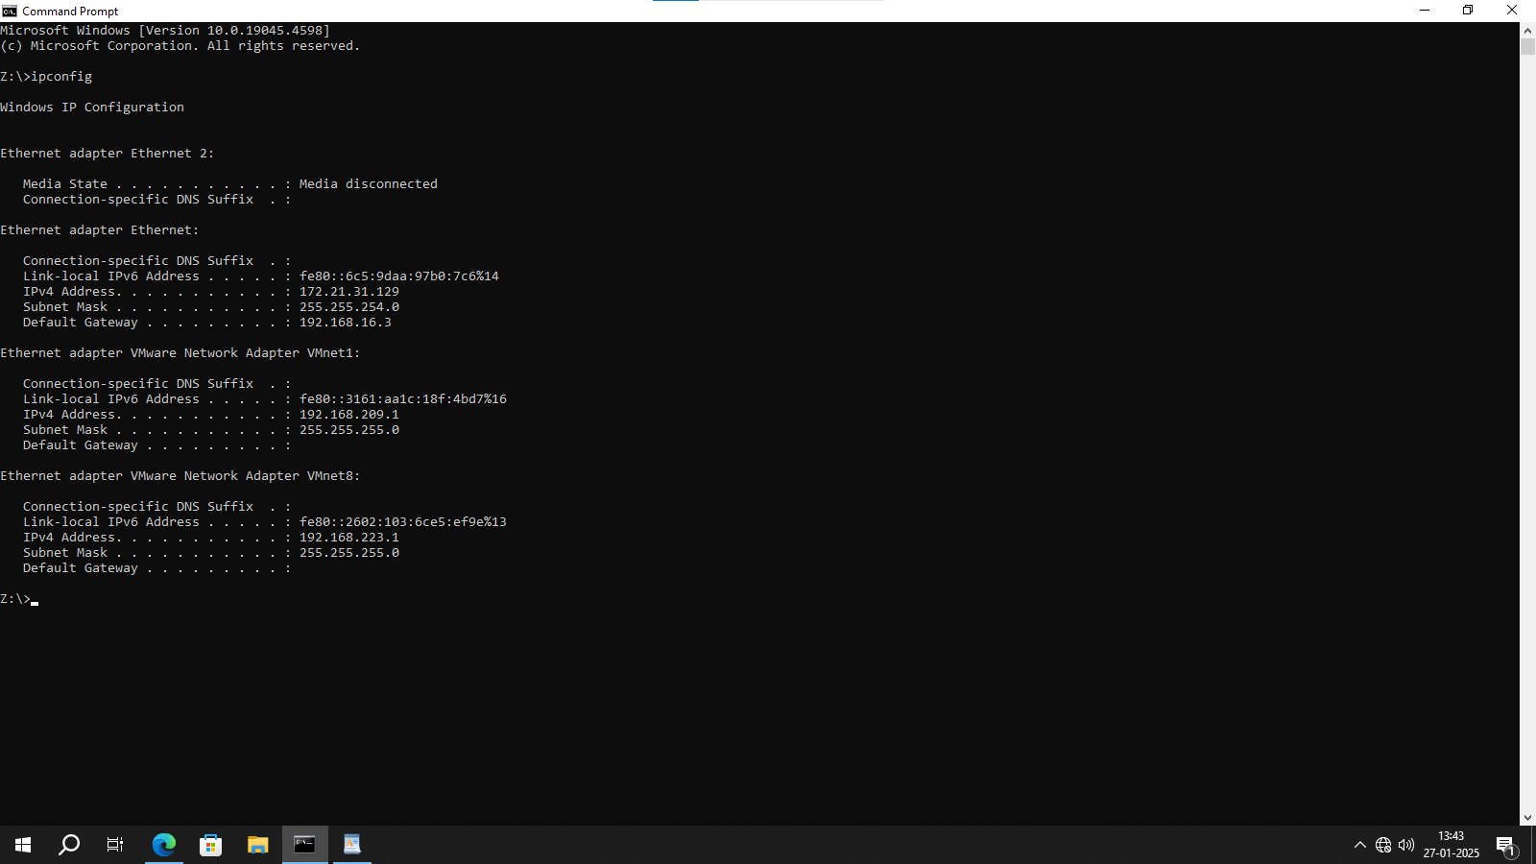

1. **ipconfig /all – Shows detailed information about all network interfaces, including MAC addresses and DNS servers.**

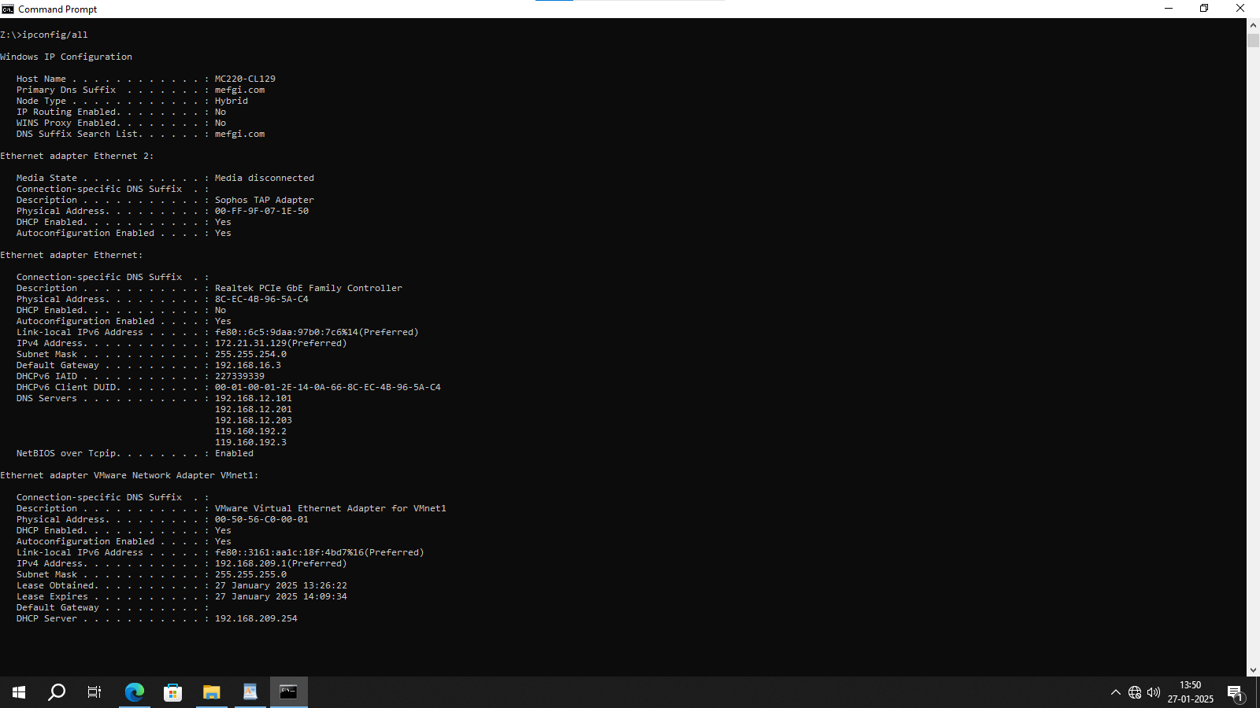

1. **hostname – Displays the computer’s hostname (system name) on the network.**

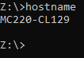

1. **getmac – Displays the MAC address of the network interfaces on the system.**

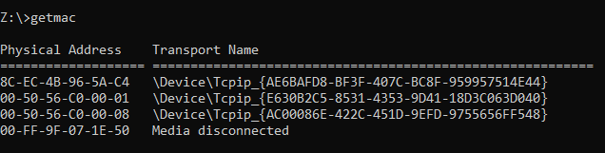

**5.systeminfo – Provides detailed information about the system configuration, including OS, memory, and network adapter info.**

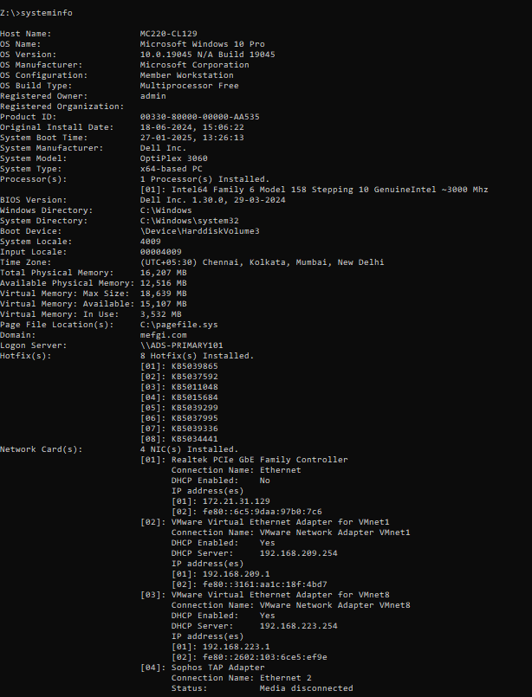

**6.ping – Sends an ICMP echo request to check connectivity to a remote host.**

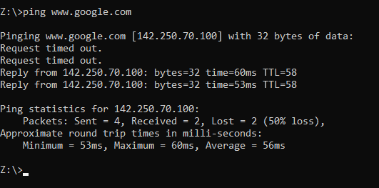

**7.** **ping {ip addr} – Pings a specific IP address to test connectivity to that address.**

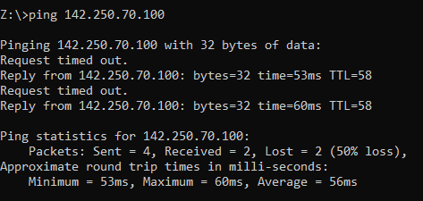

**8.** **tracert – Traces the route packets take to reach a destination, showing the hops along the way.**

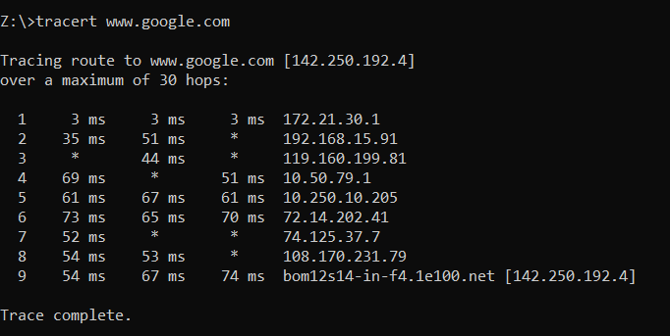

**9.** **route print – Displays the routing table, showing routes and associated network interfaces.**

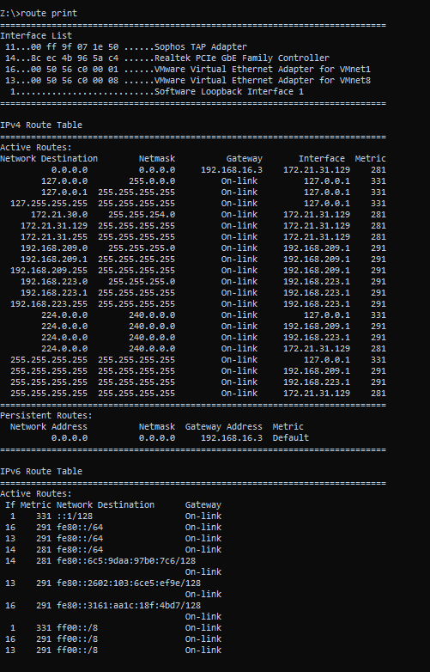

**10.** **pathping – Combines the functionality of ping and tracert, providing packet loss and latency information at each hop.**

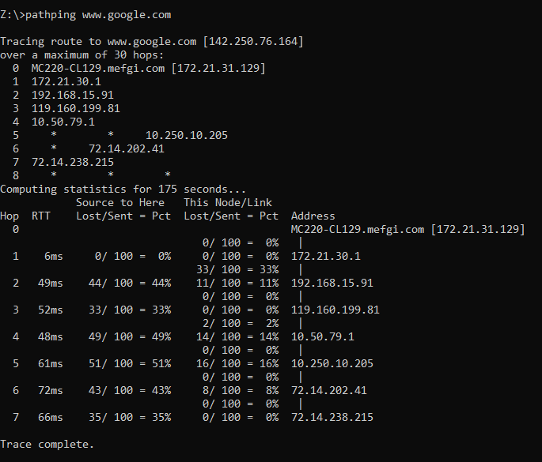

**11.** **arp -a – Displays the current ARP (Address Resolution Protocol) table, mapping IP addresses to MAC addresses.**

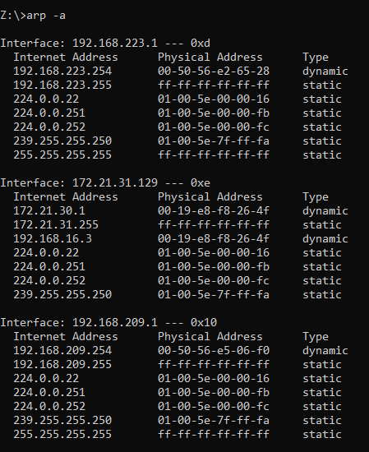

**12.** **nslookup – Queries DNS servers to obtain domain name or IP address information.**

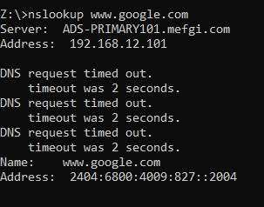

**13.** **netstat – Displays active network connections, listening ports, and routing table.**

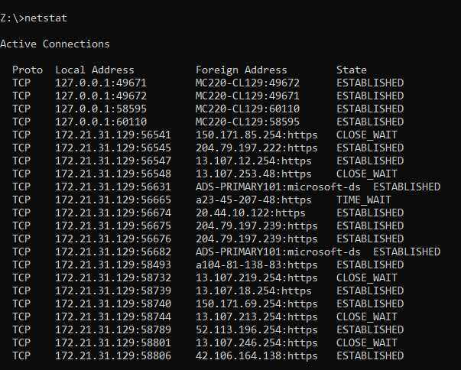

**14.** **netstat -a – Shows all active connections and listening ports.**

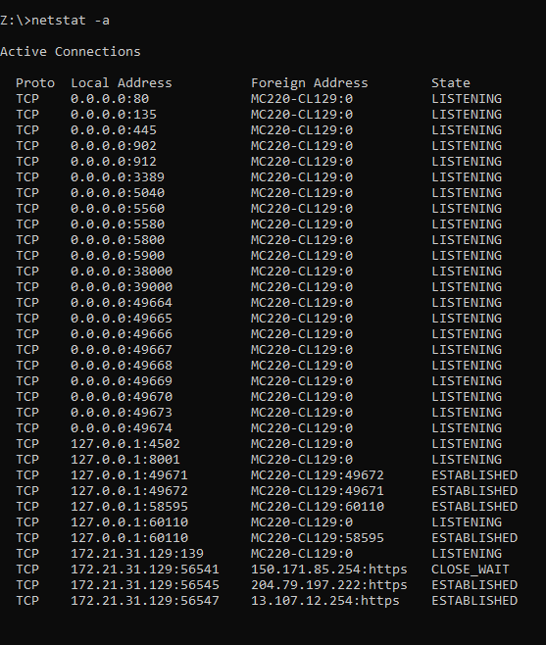

**15.** **netstat -e – Displays Ethernet statistics, such as the number of bytes and packets sent/received.**

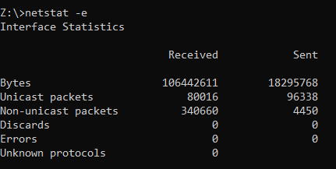

**16.** **ipconfig /flushdns – Clears the DNS resolver cache to force fresh DNS lookups.**

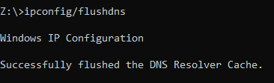

**17.** **nbtstat -r – Displays NetBIOS over TCP/IP statistics, including the resolution of names from the NetBIOS name cache.**

